CHEM-115 Quiz 9 (Chapter 14) December 8, 2017

Name: ______________________ Section: ______
- What is the first common molecule that all major catabolic pathways end up producing during the breakdown of lipids, carbs or proteins?
- Pyruvate b) Glucose c) Acetyl-CoA d) Citrate

- The major functional group that Coenzyme-A uses to combine with other molecules during various catabolic pathways is its ___________ group.
- Amide b) Alcohol c) Ether d) Sulfhydryl (aka. thiol) e) Amine

- The three “oxidative decarboxylation” reactions that occur in the intermediate step & citric acid cycle all produce CO₂ and ____________.
a) NADH b) FADH₂ c) acetyl-CoA d) citrate e) protons

- Both beta-oxidation & the citric acid cycle occur in what cellular compartment?
- Cytosol b) mitochondrial matrix c) ribosome d) mitochondrial intermembrane space
- The diagram below summarizes the 6th step of the TCA cycle. What kind of reaction is occurring?
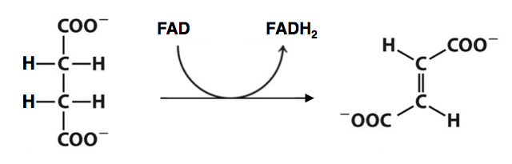
- hydrolysis
- hydration
- redox
- isomerization

- NADH releases its electrons into _________, whereas FADH₂ releases them into ___________.
a) Complex I; Complex II c) Both Complex I e) Complex III; Complex IV
b) Complex II; Complex I d) Complex II; Complex III

- Which of the following molecules serves as a mobile electron carrier in the electron transport chain? Circle all that apply.
a) Coenzyme-A b) Coenzyme-Q c) Cytochrome C d) pyruvate

- Which of the electron transport chain complexes does not “pump” protons (H⁺)? Circle all that apply.
- Complex I b) Complex II c) Complex III d) Complex IV e) All do

- What form of energy is stored in the proton gradient used to drive ATP synthase?
a) potential b) kinetic c) thermal d) chemical

CHEM-115 Quiz 9 (Chapter 14) December 8, 2017

Name: ______________________ Section: ______

- The citric acid cycle enzymes are located in the ___________, while the electron transport chain complex are located in the ___________.
- Cytosol; mitochondrial matrix c) Mitochondrial matrix; inner mito membrane
- Mitochondrial matrix; outer mito membrane d) Inner mito membrane; cytosol
- Which of the following macromolecules we have studied produces acetyl-CoA as an intermediate in it catabolism? Circle all that apply.
- Carbohydrates b) Proteins c) Fatty acids d) Sterols

- The three “oxidative decarboxylation” reactions that occur in the intermediate step & citric acid cycle all produce CO₂ and ____________.
a) FADH₂ b) acetyl-CoA c) citrate d) NADH e) protons

- The major functional group that Coenzyme-A uses to combine with other molecules during various catabolic pathways is its ___________ group.
- Sulfhydryl (aka. thiol) b) Ketone c) Amine d) Alcohol e) Aldehyde
- The diagram below summarizes the 2nd step of the TCA cycle. What kind of reaction is occurring?
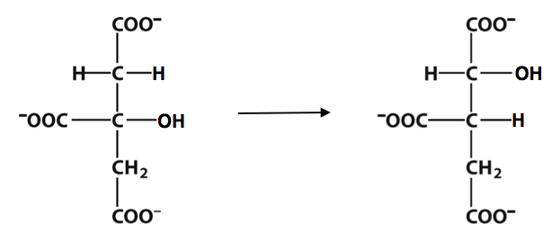
- hydrolysis
- hydration
- redox
- isomerization

- FADH₂ releases its electrons into _________, whereas NADH releases them into ___________.
a) Complex I; Complex II c) Complex II; Complex I e) Complex III; Complex IV
b) Both Complex I d) Complex II; Complex III

- What form of energy is stored in the proton gradient used to drive ATP synthase?
a) potential b) kinetic c) thermal d) chemical

- Which of the following molecules serves as a mobile electron carrier in the electron transport chain? Circle all that apply.
a) Coenzyme-Q b) Coenzyme-A c) citrate d) Cytochrome C

- Which of the electron transport chain complexes does not “pump” protons (H⁺)? Circle all that apply.
- All of them do b) Complex I c) Complex II d) Complex III e) Complex IV

